**Belair Middle School**

**Learning Commons**

**Handbook**

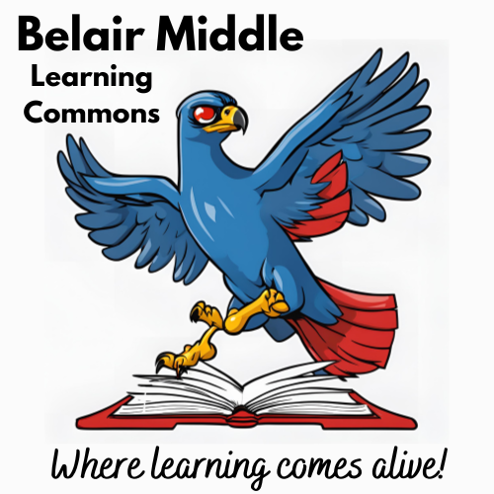

**Principal - Mrs. Ca’Vanna Lambert**

**Media Specialist - Mrs. Dixie Shoemaker**

**Rev. 2024**

**Overview**

This handbook has been designed as a guide to inform you of the Learning Commons’ policies and procedures. It also includes Richmond County Board of Education policies in the Department of Educational Media and Technology.

As the media specialist, I am available to support you with any instructional needs. I am happy to assist you in finding the right book, textbook, video, software, equipment, and/or information from our (*soon to be*) vast selection of print and non-print resources.

The media specialist also serves as an instructional partner with teachers to collaborate on a lesson(s) and serves as a teacher in instructing students on information/digital literacy skills and orienting them to the policies and procedures of the media center.

**Mission Statement**

The aligned mission of the Belair Middle Learning Commons is to create a safe, nurturing environment for all patrons to have free access to information. The learning commons wishes to inspire a love of reading and a passion for knowledge, to support the instructional goals of the school, and provide students with the information literacy skills needed for success in the globally diverse 21st Century.

**Vision Statement**

The programs of the Learning Commons will help prepare students to be lifelong learners, independent critical thinkers, and prepared for the diverse and unknown future.

**Goals of the Learning Commons**

* To promote and support the instructional curriculum by providing various resources in each subject area.
* To provide for the growth of readers by having books that support the school's reading needs.
* To orient students and teachers so that they can utilize the Learning Commons and its resources independently.
* To promote the enjoyment of reading
* To promote and utilize instructional and informational technology that will enhance instructional programs.
* To provide materials which represent various religious, ethnic, cultural, social, and other groups of people.
* To provide materials from various points of view that support students’ abilities to develop skills necessary for critical reading, thinking, and listening.

**Hours of Operation and Scheduling**

The Learning Commons shall provide open and flexible access of availability to all stakeholders per Georgia code 160-4-4-.01 Section 1, which states

School media programs should include a plan for flexibly scheduled media center access for students and teachers in groups or as individuals simultaneously throughout each instructional day. Accessibility shall refer to the facility, the staff, and resources, and shall be based on instructional need.

The Learning Commons is open from 9:30 a.m. to 4:00 p.m. every school day for students, 8:40 a.m. to 4:30 p.m. for teachers, and before and after school on an “as-needed” basis. It is closed to students for 30 minutes a day for lunch. Our schedule is flexible in that students, faculty, and staff may come to the Commons at any time when it is open. Students may come individually or in small groups. Teachers wishing to bring an entire class to the Learning Commons should schedule a time with the media specialist using the organization system in place. It is a Richmond County Board of Education policy that teachers must accompany and monitor their class while in the Commons. Only one entire class at a time may come to the center because students come to use our facilities throughout the day and the Commons often becomes crowded.

**Policies of the Learning Commons**

Coming to the Learning Commons is a privilege. To maintain this privilege, patrons (students, staff, visitors, etc.) must follow the following procedures for use:

1. All patrons (students and adults) should sign in using the computer by the door.

2. *Students* ***must come with a PETS pass*** from their teacher giving them permission to be in the media center. The media specialist has template PETS passes if you want to use them. You do not have to use the provided template, but ALL passes must still have all four elements of the PETS pass.

What’s on a PETS Pass?

**P – Purpose** – What is the student supposed to be doing? (checking out a book, completing an assignment, conducting research, free reading time, etc.)

**E**- **Expectation** – Is this group work? Individual work? Do they get “free time” after the task if time left, or should they report right back to class?

**T**– **Time**What time did you send them, what time to return or length of stay in minutes

**S – Signed** – Signed and dated by the teacher!

2. Students will be on task while they are in the Commons, meaning that students are doing what they came to do (i.e., checking out a book, doing research, returning books, paying a fine, etc.). If they are observed acting inappropriately (depending on the behavior), the media specialist will give that student a warning. The second time the student is reprimanded, the student will be sent back to class.

3. ***No food, candy, or drinks*** are allowed in the Commons. **This rule applies to all patrons** (students, staff, etc.). Water bottles are allowed if they can be closed to prevent leaks. If a student has any of these items while in the library, they will be sent back to class to return the items or be asked to dispose of them.

4. Patrons will show respect for each other in the Commons. Failure to do so could result in being asked to leave.

5. Any serious discipline problems will result in a referral to the teacher, principal or assistant principal.

6. Students caught running in the hall to the library will be sent back to class.

7. Patrons are encouraged to use the space as needed as part of the library program. It is expected that any patron (this includes adults) moving materials, furniture, etc., will return the items to their proper locations before leaving the media center.

The following **Essential Agreements** will be posted in the Commons to remind patrons of these procedures, and all will be reviewed during Orientation.

1. We will respect the Learning Commons space and its contents.
2. We will cooperate with adults and peers.
3. We will show integrity through our words and actions.

**Circulation/ Student Accountability/Fines**

Student check out limit: 3 books, 1 must be in Lexile range**

\*\**Students who owe fines or books to any Richmond County School are limited to a 1 book checkout until they clear their accounts. That one book must be a Lexile book.*

Books are checked out for two-week periods. Reference books may not be circulated. Students are organized by homeroom in the Destiny online system. When a student wishes to check out a book, he/she goes to the check-out station, finds their homeroom class number from the drop-down menu, selects their name from their class, and then scans the book under the scanner. To return books, students move to the check-in station, scan the book, and place it in the return bin.

If a student loses a book or damages it beyond use, he/she will be charged the replacement cost of the book. Removal of any labels from the books will result in fines to replace said labels. Notices of fines and/or overdue books are sent out to parents periodically. Students must clear all fines and return all books before the end of the school year or before they withdraw from school to receive their report card. Students who owe fines cannot register at their new school until all books and fines on that student's record are returned and/or paid. Students who return to the school and still have outstanding books and/or fines will also be limited to a 1 book checkout limit until this debt is completely paid.

* Removed bar code/spine label/level label $1.00 ea.
* Liquid damage, excessive writing/coloring, Replacement cost of book

torn/missing pages, food/gum, missing cover, etc.

**Teacher Use of Resources**

Teachers are welcome to use and check out the many print and non-print resources in the Learning Commons. Some equipment, such as document cameras, may be checked out for the entire year and all parts of the equipment must be kept together for inventory purposes. For example, all parts of a computer (CPU, monitor, keyboard, mouse, printer, etc.) must be kept together. When showing a video, teachers are required to specify the video that they will be showing in their lesson plans, and the video must be from an approved source (**NO Netflix, Hulu, Disney, or other personal subscriber platforms**). See Copyright section for more information on this topic.

A variety of materials are available for teachers to preview and check out. The person who checks out the material is responsible for it. If an item(s) is lost or damaged, the teacher should contact the media specialist to find out the replacement cost of that material and pay for the lost/damaged item.

**Textbook/TE Addendum**: Teachers are issued teaching materials purchased by Richmond County School System, representing a significant investment of time and money. Teachers are responsible for the proper care and organization of county issued textbooks, TE’s, materials, etc. They should be returned in the complete set and condition (with normal wear and tear) with which they were issued. Teachers losing materials or returning incomplete sets may be asked to compensate the cost of the materials.

**Cooperative Planning and Instructional Materials Request**

The media specialist is excited to offer teachers assistance with their lessons. Teachers requesting or needing assistance with books, videos, or other materials need to request materials from the media center *in writing* (an email is perfect!). This request must be submitted at least one week prior to the date needed to give the media specialist time to organize and find the requested materials. Requests not submitted in a timely manner may not be honored in the time needed. We offer the following services: (*not an exhaustive list*)

• Preselect groups of books on a certain topic under study (please give as much information as possible so your materials are relevant)

• Place books on reserve for students to use in the media center

• Help teachers locate materials to enhance lessons

• Plan a lesson/unit with the teacher on literacy skills

Lessons in the media center are part of a cooperative process that takes place with the teacher(s) to support instruction and the development of digital and information literacy. Planning with the teacher(s) and media specialist must take place *prior* to scheduling lesson delivery.

**Lamination**

Teachers may submit instructionally related materials to the Commons to be laminated. Lamination will be completed on Mondays. There will be a designated place to leave materials for lamination. Please make sure your name is written on the back of the materials or attach a note. Please ensure you pick up your laminated items in a timely manner.

**Media and Technology Building Committee**

Each school shall have a Building Media and Technology Committee. This committee shall be composed of administrative, instructional and media personnel, parents, students, and community representatives. The committee will meet with the media specialist regularly to discuss the annual media plan and policies, and to recommend and guide decisions for the media center.

The media specialist shall be responsible for organizing and working with the Building Media and Technology Committee. A list of committee members shall be turned into the Director of Educational Media and Technology at the beginning of each academic year.

The media specialist shall be guided by, but not limited to, the suggestions of the Building Media and Technology Committee. It is, and shall remain, the media specialist's responsibility to order all print, non-print and audio-visual materials and equipment to ensure a balanced collection is available for instructional use in the media center and to plan programming for the school’s needs.

**Weeding/Inventory**

The media specialist periodically weeds or removes books, materials, and equipment that are damaged, worn out, and/or out of date. Weeded materials, once they are removed from the circulation system, if still in usable condition, are sometimes offered to faculty and/or students.

**Acquisitions/Ordering/Selection of Materials**

The media specialist receives a state allotment each year to order books, videos, software, and other materials. According to the present accrediting agency, a school must provide at least ten books per student. Each year, the media specialist orders new materials, with input from teachers and students, that would help provide the most current and requested resources. The selection of materials for the Learning Commons is an ongoing process.

The following criteria will be used as a guide for selecting media materials:

* Relevance to curriculum

• Interests/backgrounds of students and teachers

• Board of Education policies

• Authority, scope, and coverage of work

• Format and price of work

• Literary excellence (award winners)

• Lasting importance/significance on a particular field

• High potential of user appeal

**Gifts**

Gifts are appreciated but will only be entered into circulation if it offers instructional benefit to the school's curriculum and adds to the strength of the Learning Commons’ collection.

**Privacy of Library Records**

Library records are confidential and will not be shared with other students or adults who do not have proper permissions. Teachers and administrators who have a valid reason for finding out information regarding a student's record must contact the media specialist.

**Intellectual Freedom (AASL 3.2, 5.2)**

Children have the right to freedom of inquiry and access to information; responsibility for abridgment of that right is solely between an individual child and the parent(s) of that child. Richmond County School System accepts the obligation to provide for a wide range of abilities and to respect the diversity of many different points of view. Varied teaching strategies and learning activities will be considered in meeting this obligation. To this end, principles must be placed above personal opinion, and reason above prejudice in the selection of materials of the highest quality and appropriateness. No individual or group has the right to impose its point of view of concepts of politics or morality upon another.

**Reconsideration of Materials**

Opinions differ, and occasionally there may be criticism of even the most carefully selected materials. In the case of a complaint, the following procedure shall be followed: The complainant shall file the complaint, in writing and on the approved form, with the school administrator (See Appendix 3 for Form for Reconsideration of Media). The school administrator shall refer the complaint to the Building Media and Technology Committee to consider the validity of the complaint. After reviewing the complaint, the committee shall read, watch or listen to the material in question and write an answer to the complainant, detailing their opinion of the item and issue a decision in a timely manner. If the complainant does not agree with the decision, an appeal to the Richmond County Board of Education must be made within ten (10) school days following the date of the committee’s decision. If an appeal is not filed within the time limit, the case shall be considered closed.

**Volunteers**

Volunteers are always welcome in the Learning Commons! There are several things that must be done, however, before someone may volunteer. First, the person must fill out a volunteer application. Then he/she must talk with school personnel about the types of jobs that he/she will be doing in the school. Applications are kept in the main office. Secondly, he/she must participate in a volunteer orientation, which is scheduled monthly through the central office of the Richmond County Board of Education. Finally, the volunteer needs to meet with the media specialist to set up an agreeable work schedule.

**Media Team and The Commons Crew**

The media specialist serves as an advisor to the Media Team. The Media Team will be responsible for the morning news show. Students must maintain passing grades and good conduct to remain a member. Students must be recommended by their teacher and try out for a place on the media team.

Interested students will be selected to be part of the Commons Crew, a group of students who help in the Commons and learn how to shelve books, organize library materials, and assist in other ways deemed appropriate.

**Technology**

**Student Device Distribution**

Student devices are checked out to students in grades 6 – 8. Students and their parents/guardians must sign the RCSS Student Technology Loan Agreement form (Visit www.rcboe.org – Parents – Power Up (*1:1 Technology – Power Up 1:1 English or Español – Power Up Student Handbook*). Suitable policies for accountability and care of the equipment have been put into place by the Richmond County School System. Please see the Power Up guide for more detailed information about student devices, fines, etc.

**Student Device Optional Insurance**

Parents have the option of purchasing device insurance and are encouraged to do so. Insurance covers the cost of lost or damaged devices. The insurance covers up to 2 devices for the student in one school year. Visit www.rcboe.org – Parents – Power Up (*1:1 Technology – Power Up 1:1 English or Español – Device Cost and Insurance*)

**Mobile Cart and Technology Guidelines**

Please adhere to the following guidelines when using the Mobile Carts.

1. Teachers must inspect computer carts before each use and complete a work order for any issues right away. Any damage that occurs while being used, or technical issues encountered, must be reported immediately using the Incident IQ tech request protocol and the tech damage form.

2. Students **are not** allowed to transport the mobile cart units. This is a manufacturer recommendation, a safety hazard, and asset protection procedure.

3. **Laptops are only to be used by the student/teacher they are assigned to**. The teacher who checked out the cart is responsible for ensuring computers are placed on the cart correctly and cared for. The teacher is responsible for having adequate procedures in place to enforce laptop responsibility among his or her students.

4. Laptops must remain secure. Please keep the laptop cart secured so that unused laptops are not accessible to anyone. If the cart is in your classroom, and the room is vacant, the door should remain locked. Carts should be LOCKED at the end of every school day if there are devices on the cart.

5. **Students should be closely monitored when using technology**. Please do not leave the classroom while technology is being used.

6. *All users* (students, staff, etc.) must adhere to the Acceptable Use Policy of the Richmond County School System. Abuse may result in inability to use technology.

On computer carts:

* One computer per slot
* Use the cord in the slot for the same slot
* Do NOT pull on the cords!

*Other Mobile equipment*: Any other mobile equipment checked out from the media center, (doc cameras, cameras, swivls, etc.) must be carefully monitored and supervised by the teachers and checked in and out in an appropriate and timely manner.

If a student accidentally or intentionally (*due to poor use, not following instructions, anger, etc*.) damages equipment, the student may be responsible for the repair/replacement cost of the device per the technology agreement. The teacher who observed the damage **must** put in a ticket in IQ, fill out a technology damage form (Appendix 1), and contact the parent. Then the form and damaged device should be turned into the Media Center so a fine (if applicable) and loaner device can be issued.

**Off-Campus Checkout of Equipment**

Teachers may check out equipment for instructional purposes, and for off-campus use if the media center has more than one piece of that equipment. The following procedures are to be used:

Borrowers must have all equipment checked out in Destiny or Incident IQ. Any materials damaged or not returned will be repaired and/or replaced at cost to the borrower. See form at back of handbook.

1. It is the borrower's responsibility to:

• Ensure the equipment is in working order when it is checked out.

• Return the material by the due date

• Return the material in working order

• Provide Police Report should the equipment be stolen or destroyed by fire.

2. It is the lender's responsibility to:

• Make sure the materials are returned on time.

• Ensure the equipment is in working order within 1-2 working days of its return by inspecting it. This ensures the equipment has not been damaged, remains virus free, and is in proper working order.

**Internet Access and Acceptable Use Policy**

Belair Middle follows Richmond County policy on Acceptable Use of the Internet. (<http://www.rcboe.org/Domain/124>) This policy applies to all computers in the building that have Internet access and any personal devices using the school’s network. The Internet is to be accessed only for instructional purposes. Students may use Office 365 e-mail per the acceptable use policy. For further information regarding internet or technology policy, please see the Richmond County Power Up guides.

**Technical Requests**

If you are experiencing trouble with technology in your classroom, you need to submit a technology ticket through a program called Incident IQ and fill out a short physical form (*for laptops only, Appendix 1*) to accompany it. You can get to Incident IQ from your Launchpad. There are videos and instructions on the RCSS website to help you if you need a refresher. There is a Canvas course with help on Incident IQ. There is a short guide as an appendix (2) to this handbook. Feel free to ask the media specialist for help in submitting a ticket as well.

**Copyright Policy and Fair Use**

All forms of expression that are recorded in some concrete form are protected by the Copyright Law, which protects materials created on or after January 1, 1978. This law gives five rights to the creator of the work: reproduction, adaptation, distribution of copies or records by sale, gift, rental, lease, or lending; public performance, and public display. The creator of the work owns these rights; he or she may sell or license these rights on any terms with which he and the requestor may agree, The law, Title 17, United States Code, Public Law 94·553, 90 Stat. 2541, as amended, gives schools and certain user's special exceptions, which are called "Fair Use." School employees can use or reproduce certain copyrighted materials if they meet defined guidelines. All fair use guidelines must be met. Be sure to observe the copyright information of any material you copy.

Persons who violate copyright can be charged up to $250,000 in a court of law and sent to prison for up to five years. The media specialist or principal can also be held responsible for violations that involve equipment checked out from the media center. Richmond County requires that **all** teachers adhere to state and federal copyright law.

For audiovisual and print materials, you can:

* Show an approved clip/video during face-to-face teaching activities (i.e., it must match your objectives and take place in a physical classroom, not posted online.)
* The performance must take place in a classroom or similar place of instruction in a nonprofit educational institution.
* The performance must be of a legally acquired copy of the work.
* Make a single copy, for use in scholarly research, or in teaching, or in preparation for teaching a class of the following: A chapter from a book, An article from a periodical or newspaper, A short story, short essay, or short poem, whether or not from a collected work, A chart, graph, diagram, drawing, cartoon, or picture from a book, periodical or newspaper.
  + Make multiple copies for classroom use only and not to exceed one per student in a class or the following: A complete poem, if it is less than 250 words and printed on not more than two pages, An excerpt from a longer poem, if it is less than 250 words, An excerpt from a prose work, if it is less than 1,000 words or 10 percent of the work, whichever is less, One chart, graph, diagram, drawing, cartoon, or picture per book or periodical.

To avoid breaking copyright law, remember that you CANNOT:

* Record a show from cable and show it in class.
* Record a show from CBS, NBC, ABC, or PBS and show it more than 10 days after it originally aired. You are supposed to erase it after the 10th day. Also, you cannot show the entire show. You can only show segments.
* Show anything above a G rating without approval.
* Show a Disney movie. (We don't pay for the rights to show Disney movies nor movies that aren’t instructionally based.)
* Show any "homegrown" movies that you've recorded from other sources.
* Make multiple copies of a short poem, article, story, or essay from the same author more than once in a class term, or make multiple copies from the same collective work or periodical issue more than three times a term.
* Make multiple copies of works more than nine times in the same class term.
* Make a copy of works to take the place of an anthology.
* Make a copy of “consumable” materials, such as workbooks.

What will happen and how will you get caught?

* School systems in violation are fined. Your "tellers" can be anyone from visiting salespersons to students who are paid to inform.
* Yes, schools have been sued. Generally, the whole system is sued and the teacher loses his/her job and the system pays the fine.
* Remember, when you sign your contract, you sign that you will abide by the laws of the state ... that includes copyright.

What can we legally show?

You can show things the school already owns or subscribes to. You can show videos from websites you/we have subscriptions to, like BrainPop and Discovery Education. You can show videos from YouTube for Schools, after you have screened them, and other education geared video sites like SchoolTube and TeacherTube.

This is not a complete list of “do’s” and “don’ts.” When in doubt about copyright law, do not use the material without first checking with the media specialist.

**What is Fair Use?**

In copyright law, there is a description that explains what fair use is, and how to decide if something is fair use. The "slippery" thing is, there is no distinct separation between what is and isn't fair use. You must go by the guidelines and decide if what you are doing fits into the Fair Use category.

First, the reason you are using the work is important when considering fair use. The following are usually acceptable reasons for using copyrighted content; criticism and commentary, education, news reporting, academic research, and parody. When using content for these purposes, however, you must also consider the amount of the content you use. You can still only use small portions of the work, and you still need to cite it.

Another thing to think about is how you are using the content. Are you just copying the content, or are you using that content to create something new and original, like with [this video](https://youtu.be/4bK8AZSYtPU?si=G8Tkm_l8X0QCfxNX)? How you use the content can affect how it fits into fair use.

The last thing to consider is whether what you are doing with the content competes with the original creator for profit. You can't take someone else's work and sell it.

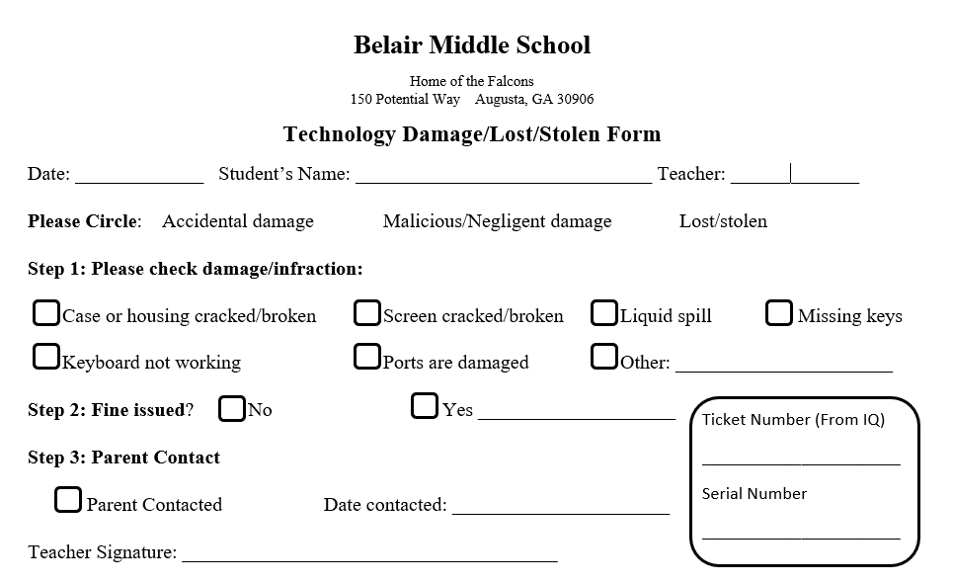

Appendix 1

**Putting in a ticket for a device (laptop/desktop) in Incident IQ**

Appendix 2

If you are placing a tech ticket for a device, please ensure you are **following ALL the steps listed below**.

* 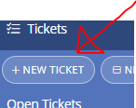Click “New Ticket” in IQ.
* 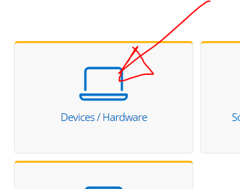Click “Devices/Hardware.”
* 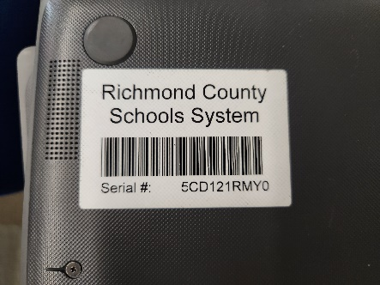In the blank at the top, **ENTER THE SERIAL NUMBER OF THE DEVICE**. The serial number is found on the barcode sticker on the bottom of the laptop, or somewhere on the side of the CPU of a desktop. If the sticker has been removed, the serial number is still printed on the actual device somewhere, it’s just really small.

Serial number sticker

Itty bitty serial number on device

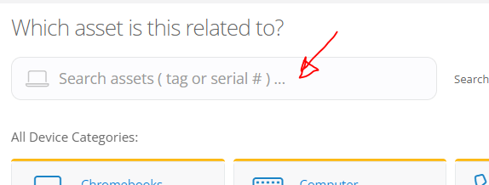

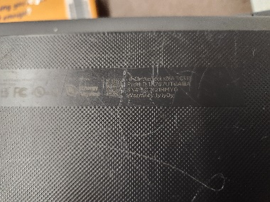

* 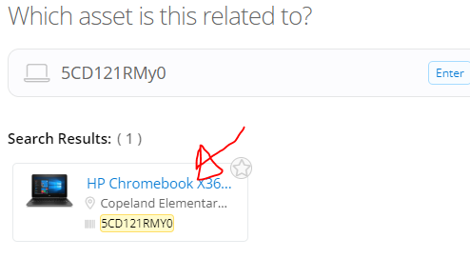Select the device after the serial number search.
* Then select whichever option best fits the issue. If none apply, select “issue not listed.” Many issues will fall under “hardware damage” (broken screens, hinges, headphone jacks, missing keys, etc.).
* Continue to select options until you get to the screen that says “describe your issue.”

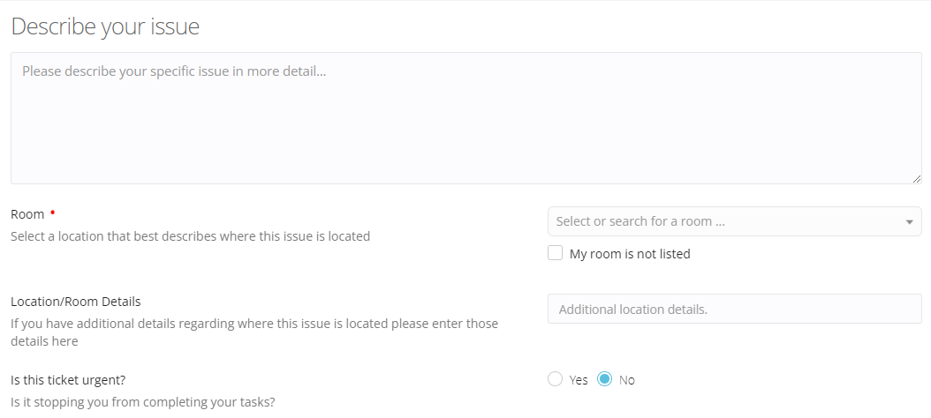

**Describe your issue.** Please be specific here and explain details of damage. Use the word “student” not student’s actual name, if applicable.

Room: Select your room if desktop, media center if laptop.

Urgent? Most aren’t (I know they are to you.)

Protected info? No if you used “student” and not name in description.

Notify additional users? Add Shoemaker. Add student.

Attach files. You can add pictures of damage if you want. (Great Documentation!)

Click “submit ticket.”

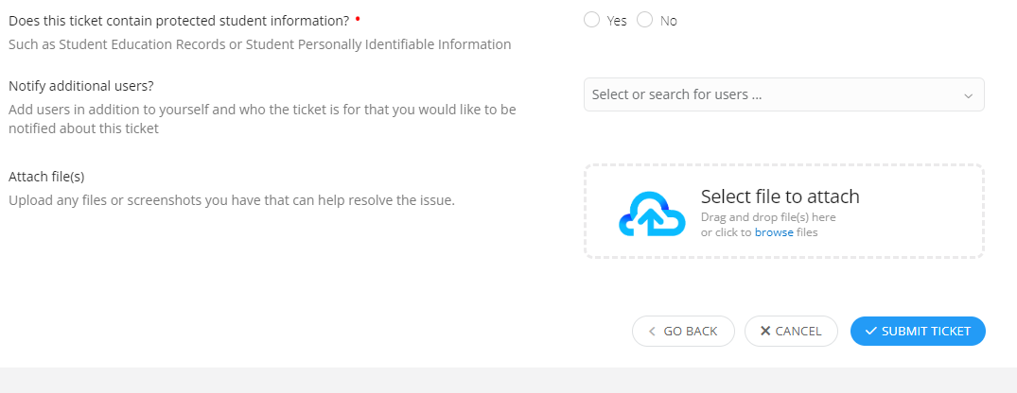

* 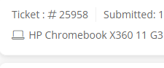After clicking “submit ticket,” fill out the technology form with the ticket number (*for laptops*)**.** Then send the laptop with form to the media center.

**Form for Reconsideration of Media**

Appendix 3

Media consists of all types of print and non-print materials.

Type of media____________________________________________________________

Name of item____________________________________________________________

Publisher and/or Author____________________________________________________

Complainant’s Name______________________________________________________

Address_________________________________________________________________

Street City State Zip

Telephone (Home)__________________________(Work)________________________

Complainant represents

_____Him/herself

_____Organization (Name)_________________________________________________

_____Other Group (Identify)________________________________________________

1. Did you read, view or listen to the *complete* item: Yes___________ No___________

2. How was the item acquired (Assignment, free selection, from a friend, etc.)

_______________________________________________________________________________

3. Is the item part of a series? Yes_______ No______

If yes, did you read, view or listen to the set or series? Yes___________ No___________

4. What is objectionable regarding the item and why? (Be specific)

_______________________________________________________________________

_______________________________________________________________________

5. Were there good sections included in the item? Yes___________ No___________

If yes, please list them: ______________________________________________

________________________________________________________________________

________________________________________________________________________

6. What do you feel might be the result of using this material?

________________________________________________________________________

________________________________________________________________________

**Form for Reconsideration of Media – Page 2**

7. What do you believe is the theme of the material?

________________________________________________________________________

8. Did you locate reviews of this item Yes_________ No__________

If yes, please cite them: ______________________________________________ If no why not?

_______________________________________________________________________

9. Did the review(s) substantiate your feelings? Yes _________No_________

10. Is there any educational merit to the item? Yes _________No_________ If yes, what do you feel would be the approximate grade level(s)______________

11. How do you see the item being utilized in an educational program?

________________________________________________________________________

12. List the person(s) with whom you have discussed this item.

Name_________________________ Title/Occupation____________________________

Address_________________________________________________________________

Street City State Zip

Telephone (Home) ________________________ (Work) ________________________

*\*\*Other persons may be listed on the back of this form.*

13. What were their reactions and/or opinions? _________________________________

________________________________________________________________________

14. What do you suggest be done with the item in question? ______________________

________________________________________________________________________

15. What do you suggest be provided to replace the item in question? _______________

________________________________________________________________________

Name of Complainant (Please Print) __________________________________________

Signature of Complainant ______________________________Date _____/_____/_____